# Verify Cluster Setup

In the Master node,

kubectl get nodes

kubectl config view

kubectl config current-context

kubectl config get-contexts kubernetes-admin@kubernetes

# Deep-dive into Master setup

kubectl cluster-info

kubectl cluster-info dump > cluster-dump

kubectl get node worker-node-1.example.com

kubectl describe node worker-node-1.example.com | less

# Look at Status(should be FALSE), Address, Capacity, and Events

kubectl get namespaces

kubectl get pods -A

kubectl get pods -n kube-system

# Look into /etc/kubernetes/ - Config, manifests & pki

kubectl get pods -n kube-system -o wide | grep proxy

service kubelet status

# Registering Working Nodes

kubectl get nodes

kubectl describe node worker-node1.example.com

kubectl delete node worker-node1.example.com

kubectl get nodes

Create a new file with Node info,

vi nodereg.json

{

"kind": "Node",

"apiVersion": "v1",

"metadata": {

"name": "worker-node-1.example.com",

"labels": {

"name": "firstnode"

}

}

}

kubectl apply -f nodereg.json

# kubectl get nodes

# Deploying the first pod and accessing it

kubectl run nginxpod --image=nginx --port 80

kubectl get pods

kubectl describe pod nginxpod

kubectl exec -it nginxpod /bin/sh

kubectl logs nginxpod

# 

# Kubernetes Dashboard

**Deploying the dashboard**

kubectl apply -f<https://raw.githubusercontent.com/kubernetes/dashboard/v2.5.0/aio/deploy/recommended.yaml>

**Verifying the Dashboard resources**

kubectl get pods -n kubernetes-dashboard -o wide

kubectl get deployment -n kubernetes-dashboard -o wide

kubectl get svc -n kubernetes-dashboard -o wide

**Editing the Service type of the dashboard**

kubectl edit svc -n kubernetes-dashboard kubernetes-dashboard

**Note:** Change the attribute after entering the deployment

type: ClusterIP (image 1) to NodePort (image 2)

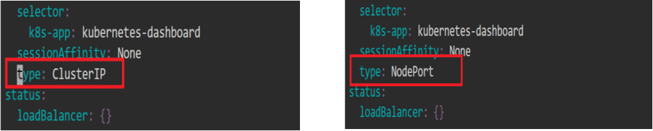

**Verifying the changes**

kubectl get svc -n kubernetes-dashboard -o wide

Note down the service(node-port) port number , here it is 31851

**Checking where the Pod is running**

kubectl get pods -n kubernetes-dashboard -o wide

kubectl get svc -n kubernetes-dashboard -o wide

kubectl get nodes -o wide

**Accessing Kubernetes Dashboard**

Click on the master tab on the lab, and then click on the desktop option.

Open Firefox browser

[**https://localhost**](https://localhost/)**:<<NodePort>>**

Example: https://localhost:31851

Click on Advanced -> Accept Risk and Continue

On the Kubernetes Dashboard,

Select **Token** from the given options and enter the token

**Note:** To get the token, navigate to the master node and use the command:

kubectl -n kube-system describe secret $(kubectl -n kube-system get secret | awk '/^deployment-controller-token-/{print $1}') | awk '$1=="token:"{print $2}'

**[OPTIONAL] Cleanup:**

kubectl delete -f<https://raw.githubusercontent.com/kubernetes/dashboard/v2.5.0/aio/deploy/recommended.yaml>

# 

# ETCD - Backup

Step 1: Get URLs and keys

kubectl describe pod etcd-master -n kube-system

Get client-URL, cert, key, and trusted-ca location

Step 2: Command

sudo snap install etcd

sudo apt install etcd-client

sudo chmod a+rw -R /etc/kubernetes/pki

sudo ETCDCTL_API=3 etcdctl snapshot save etcd_backup.db \

--endpoints https://<cluster-ip>:2379 \

--cert=/etc/kubernetes/pki/etcd/server.crt \

--key=/etc/kubernetes/pki/etcd/server.key \

--cacert=/etc/kubernetes/pki/etcd/ca.crt

Step 3: Verify

sudo ETCDCTL_API=3 etcdctl --write-out=table snapshot status etcd_backup.db \

--endpoints https://<cluster-ip>:2379 \

--cert=/etc/kubernetes/pki/etcd/server.crt \

--key=/etc/kubernetes/pki/etcd/server.key \

--cacert=/etc/kubernetes/pki/etcd/ca.crt

# 

# Upgrading Kubernetes Cluster

**Finding the latest release of Kubernetes**

sudo curl -fsSLo /usr/share/keyrings/kubernetes-archive-keyring.gpg https://packages.cloud.google.com/apt/doc/apt-key.gpg

sudo apt-get update

sudo apt-cache madison kubeadm

sudo apt-cache madison kubectl

Reference: https://kubernetes.io/releases/

**Verifying the current version of Kubernetes**

kubeadm version

kubectl get nodes

**Upgrading the repositories**

sudo apt update

sudo apt upgrade

**Holding the Kubernetes versions**

sudo apt-mark hold kubeadm

sudo apt-mark hold kubelet kubectl

**Upgrading the control plane(Master)**

sudo apt-get install -y kubeadm=1.23.17-00 --allow-change-held-packages

sudo apt-get install -y kubelet=1.23.17-00 kubectl=1.23.17-00 --allow-change-held-packages

**Verifying the updated version of Kubernetes**

kubeadm version

kubectl get nodes

sudo kubeadm upgrade pla**n**

